Theme: Building Innovative Care Where It Matters Most.
Focus Day | Celebration
Sunday, Aug 2 | - Celebrating our History  - Kick off National Health Center Week with a look at the incredible innovation CHCs provide to their communities. From serving a handful of communities to now reaching 1 in 7 Americans, CHCs have become a cornerstone of community health.  - Highlight on social media “then and now” KCCHC started 2017 at Main location on Up Gilchrist Rd and now we have 6 HC’s + Counselor's at New Directions and Centerburg Local Schools @Dexter Ohaeri have draft available July 22 9 am
Monday, Aug 3 | - Staff Appreciation Day  - CHCs thrive because of their dedicated clinical and non-clinical staff. This day honors all employees and their vital contributions to patient care and organizational success. Let’s emphasize the importance of valuing everyone on the team.  - Distribute personalized thank-you notes to all staff with lanyards  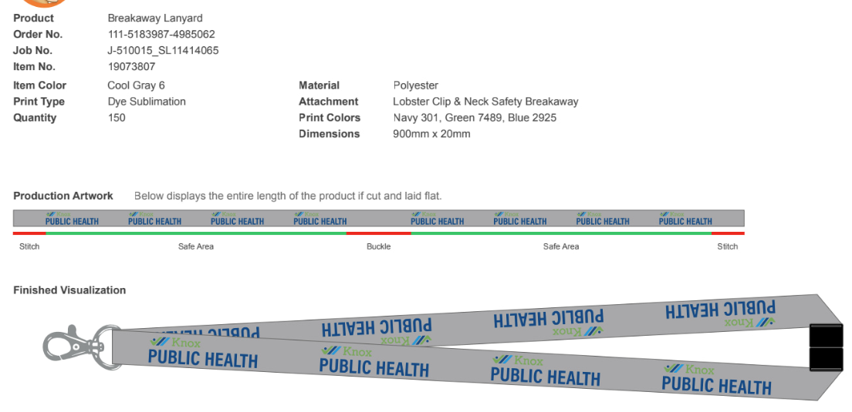  - Deliver cookies to all locations  - Post posters in lobbys for patients to leave positive comments and patients draw them selfies – PR to have complete by July 30  - Staff Spotlight on Social Media https://www.facebook.com/share/r/14gx5Xu4K1F/ -
Tuesday, Aug 4 | - Patient Appreciation Day  - Patients are at the heart of CHCs, and this day recognizes their role in shaping care delivery. We celebrate patient boards—a revolutionary model of governance where patients make up 51% or more of board members—and their contributions to the health center movement.  - Highlight our Co-App Board members on Social Media @Dexter Ohaeri draft due 7/22 9 am  - Mount Vernon Health Center Open House  Tuesday, August 4  12:00 p.m. – 12:45 p.m.  202 W. Vine Street  - Attendees BOH/Co-App Board Members and Ohio State Representative for district 98 Mark Hiner  - Give away KPH notebooks and Sticky notes  - Proclamation @Nicole Lybarger due July 31
Wed, Aug 5 | - Health Conditions Focus Day  - Patients are at the heart of CHCs, and this day recognizes their role in shaping care delivery. We celebrate patient boards—a revolutionary model of governance where patients make up 51% or more of board members—and their contributions to the health center movement.  - Health Fair @ Danville HC with Payers  Wednesday, August 5  1:00 p.m. – 3:00p.m.
Thurs, Aug 6 | - Population Focus Day  - CHCs serve patients of all race and ethnicities, in rural, urban, suburban, island and frontier communities. This includes maternal and child health, adults, elders/ older adults, veterans, agricultural workers, and those experiencing homelessness, to name a few. This day celebrates CHCs’ commitment to understanding the unique needs of their patients and communities, and providing quality, accessible care.  - Suggestions for Celebration: Organize drives to collect supplies (wellness kits, school supplies, food items, etc.)  https://www.instagram.com/reel/DXoGwVLDNnA/
Friday, Aug 7 | - Partner Appreciation Day  - CHCs succeed through collaboration with public, non-profit and industry partners. From hospitals to schools, businesses to government leaders, food banks to public housing, these partnerships drive innovation and advance health.  - Main Health Center 9 am – 3 pm  - American Red Cross Blood Drive  - Dental Education and providing toothbrushes  - Car Seats  - Cribs for Kids  - Sleep Baby Safe and Snug books  - Mount Vernon Health Center 9am – 1 pm  - The Ohio State University Mammography Bus  - Senior Health and Wellness  - Mobility Management – MVHC  - Immi Education –  - WIC – MVHC  - Tick Education  - Tick Tools  - Any interested in inviting health profession schools to participate in your National Health Center Week (NHCW) activities.  - Examples of ways schools can participate include:  - Assisting with health or biometric screenings  - Providing health education  - Hosting a table to share their academic programs and career pathways with youth and adults who may be interested in starting or returning to school
Sat, Aug 8 | - Gratitude and Future Vision  - Close the week with a focus on gratitude for all who contribute to the CHC mission and a vision for the future. Together, we aim to serve 1 in 3 Americans, ensuring health for all.

ACTION ITEMS
Healow App – Somebody at every location to help patients
Danville HC | Who | KCD | Who
Monday |  | Monday
Tuesday |  | Tuesday | Dawn
Wednesday | Christi | Wednesday | Tyler
Thursday |  | Thursday | Tyler
Friday | Are they open Friday’s in August? | Friday | Dawn
MVHC | Who | BH | Who
Monday | Christi | Monday
Tuesday |  | Tuesday
Wednesday |  | Wednesday
Thursday |  | Thursday
Friday |  | Friday
Main | Who
Monday
Tuesday
Wednesday
Thursday
Friday
Monday | Staff Appreciation Day  - Appreciation Cards  - Anggie is making cards  - Directors to write appreciation note for their staff  - https://www.facebook.com/share/r/14gx5Xu4K1F/  - Cookies  - 24 pk (3 varieties) $9.99  Lanyards
  Qty | Location
  1 | Danville Dental
  1 | Danville HC
  2 | BH
   | MVHC
   | Main
  1 | WIC
   | Admin House
Tuesday | - Patient Appreciation Day  - Invite list  - BOH/Co-App Members  - Senator Brenner  - Matt Starr – Confirmed  - Danville Mayor – Joe Mazzari  - Madison Sarvers  - County Commissioners  - Knox Pages – Confirmed  - Food from Kroger
  Qty | Price | Description
  2 | $31.99 | Assorted Pinwheel Platter feeds 12-16
  1 | $18.99 | Assorted Cubed Cheese
  1 | $18.99 | Veggie Tray with Ranch Dip
  2 | $6.59 | Case of water
Wednesday | - Health Conditions Focus Day  CONFIRMED:  - Humana  - Buckeye Mobile Unit & Buckeye Rep  - CareSource  - Conway Pharmacy  PENDING:  - Molina (Tentatively confirmed)  - Food from Kroger  Mike Scott to take tables to Danville.
  Qty | Price | Description
  1 | $18.99 | Assorted Cubed Cheese
  1 | $18.99 | Veggie Tray with Ranch Dip
  1 | $6.59 | Case of water
Friday | - Partner Appreciation Day  - Main Health Center 9 am – 3 pm  - American Red Cross Blood Drive  - Dental Education and providing toothbrushes  - Car Seats  - Mike Whitacker will provide education material)  - Table will not be maned  - Mount Vernon Health Center 9am – 1 pm  - The Ohio State University Mammography Bus  - Senior Health and Wellness  - Mobility Management – MVHC  - Immi Education –  - Can Katie Harmer? If so, schedule will need to be closed for the day  - WIC – MVHC  - WIC is closed that Friday  - Tick Education  - PR will provide info material, tick game  - Colorguard  - Giveaways  - Sticky note  - Notebooks  - Board books – Thank you for keeping meLead -Free and Sleep Baby safe and snug  - Lego’s  - Too Hot for Tots Bath Thermometer  Mike Scott to take tables and tents to MVHC
  Qty | Price | Description
  2 | $6.59 | Case of water
2 Giveaway Baskets  (Items have been ordered) | Your Health, Your Wellness  - Insulted Water Tumbler  - First Aid Kit  - Digital Thermometer  - Pill Organizer  - Reuseable Hot/Cold Pack  - Hand Sanitizer  - Lip Balm  - SunScreen  - ToothBrush  - Mouth Wash  - Activity Tracker  - Lock Box  - Tote Box  Ready, Set, Prepared!  - 24 can cooler  - Insulted Water Tumbler  - First Aid Kit  - Work Gloves  - Hand Sanitizer  - Tick Removal tool  - Emergency Blanket  - Weather emergency radio, hand crank, portable powerbank, flashlight  - Pill Organizer  - Lock Box

